Network Intrusion Detection for Cyber Security using KNN

Project Id: ALML -09

Student Name: ASMITA (TEAM LEADER)
University Roll number: 2028676
Section: U

Student Name: NEHA NEGI
University Roll number: 2028455
Section: U

Student Name: ADITI SHARMA
University Roll number: 2028618
Section: U

TABLE OF CONTENTS
- Problem Description…………………………………………………..…..3-5
  - Dataset Description……………………………………………………4
  - Flow diagram…………………………………………………………..5
- Modules for Project Implementation…………………..………………….6-7
  - Modules Used……………………………………………………..…..6
  - Platform Used………………………………………………………….7
- Machine Learning model/ Searching Technique used 7-8
- Evaluation metrics used 8
- Results and Visualizations 9-13
- Conclusion and Future Scope 14
- References 15

- Problem Description
Cyber security has become an important concern in today’s digital world because organizations continuously exchange large amounts of data through computer networks. These networks are vulnerable to cyber attacks such as unauthorized access, malware attacks, denial-of-service attacks, and suspicious activities. Monitoring network traffic manually is difficult due to the huge amount of data generated every second.
The main objective of this project is to develop a Network Intrusion Detection System using Machine Learning techniques that can automatically identify malicious network traffic and distinguish it from normal traffic. The system analyzes different network-related features and predicts whether the traffic is safe or suspicious.
This project uses various machine learning algorithms such as:
- Logistic Regression
- K-Nearest Neighbors (KNN)
- Decision Tree
- Random Forest
- Support Vector Classifier (SVC)
To improve the performance and efficiency of the models, feature selection techniques such as Forward Feature Selection and Backward Feature Elimination are applied. These techniques help in selecting the most relevant features from the dataset, reducing complexity, improving accuracy, and minimizing overfitting.
The project is carried out through several important stages. Initially, the dataset is collected from a reliable source containing both normal and attack-related network traffic records. In the preprocessing stage, missing values, duplicate entries, and irrelevant data are handled properly. Categorical values are converted into numerical form, and feature scaling techniques such as StandardScaler or MinMaxScaler are applied to normalize the data. After preprocessing, the dataset is divided into training and testing sets for model development and evaluation.
The selected machine learning models are then trained using the training dataset. Hyperparameter tuning techniques are used to optimize the performance of each model and achieve better prediction accuracy. The models are evaluated using performance metrics such as accuracy, precision, recall, F1-score, confusion matrix, and ROC curve analysis. Data visualization techniques including correlation heatmaps, bar graphs, and performance comparison charts are also used to better understand the dataset and model results.
The final outcome of this project is an intelligent intrusion detection system capable of detecting suspicious network activities with high accuracy and efficiency. The system helps in strengthening cyber security, reducing manual monitoring efforts, improving threat detection speed, and protecting organizations from potential cyber attacks. This project demonstrates how Machine Learning can play a significant role in enhancing modern network security systems and building smarter cyber defense mechanisms.

1.1 Dataset Description

The dataset used in this project is collected from Kaggle and is related to Network Intrusion Detection. The dataset contains detailed information about network traffic behavior and various network-related parameters that help in identifying suspicious or malicious activities within a computer network. It includes both normal and attack-based traffic records, making it suitable for training and testing machine learning models for intrusion detection purposes.

The dataset used in this project is collected from Kaggle and is related to Network Intrusion Detection. The dataset contains detailed information about network traffic behavior and various network-related parameters that help in identifying suspicious or malicious activities within a computer network. It includes both normal and attack-based traffic records, making it suitable for training and testing machine learning models for intrusion detection purposes.

•Packet_Size:Represents the size of the transmitted network packet.
•Connection_Duration: Indicates the total duration of a network connection.
•Error_Rate: Shows the frequency of errors occurring during communication.
•Protocol_Type: Specifies the type of network protocol used, such as TCP, UDP, or ICMP.
•Source_Bytes: Represents the amount of data sent from the source machine.
•Destination_Bytes : Represents the amount of data received by the destination machine.

Apart from these, the dataset may also contain additional network-related attributes that contribute to improving the detection capability of the machine learning models.

The target column in the dataset is used for classification and contains two classes:
• 0→ Normal Traffic
• 1 → Malicious Traffic

Here, normal traffic represents safe and legitimate network activity, while malicious traffic represents suspicious or attack-related behavior such as unauthorized access attempts, malware activity, or denial-of-service attacks.

Before training the machine learning models, the dataset undergoes several preprocessing steps to improve data quality and model performance. In the preprocessing stage, missing values are identified and handled appropriately to avoid incorrect predictions. Duplicate records are removed to reduce redundancy, and inconsistent or noisy data entries are cleaned to ensure accuracy and reliability.

Since machine learning algorithms work more effectively with properly formatted numerical data, categorical features such as protocol types are converted into numerical form using encoding techniques. Additionally, feature scaling is applied using StandardScaler to normalize the feature values. This step is important because some machine learning algorithms, especially K-Nearest Neighbors (KNN) and Support Vector Classifier (SVC), are highly sensitive to differences in feature ranges. Scaling helps in bringing all features to a similar range, improving model accuracy and training efficiency.

The preprocessed dataset is then divided into training and testing datasets, allowing the models to learn patterns from historical data and evaluate their performance on unseen network traffic data. This prepared dataset forms the foundation for building an effective and reliable Network Intrusion Detection System using Machine Learning techniques.
  - Architecture
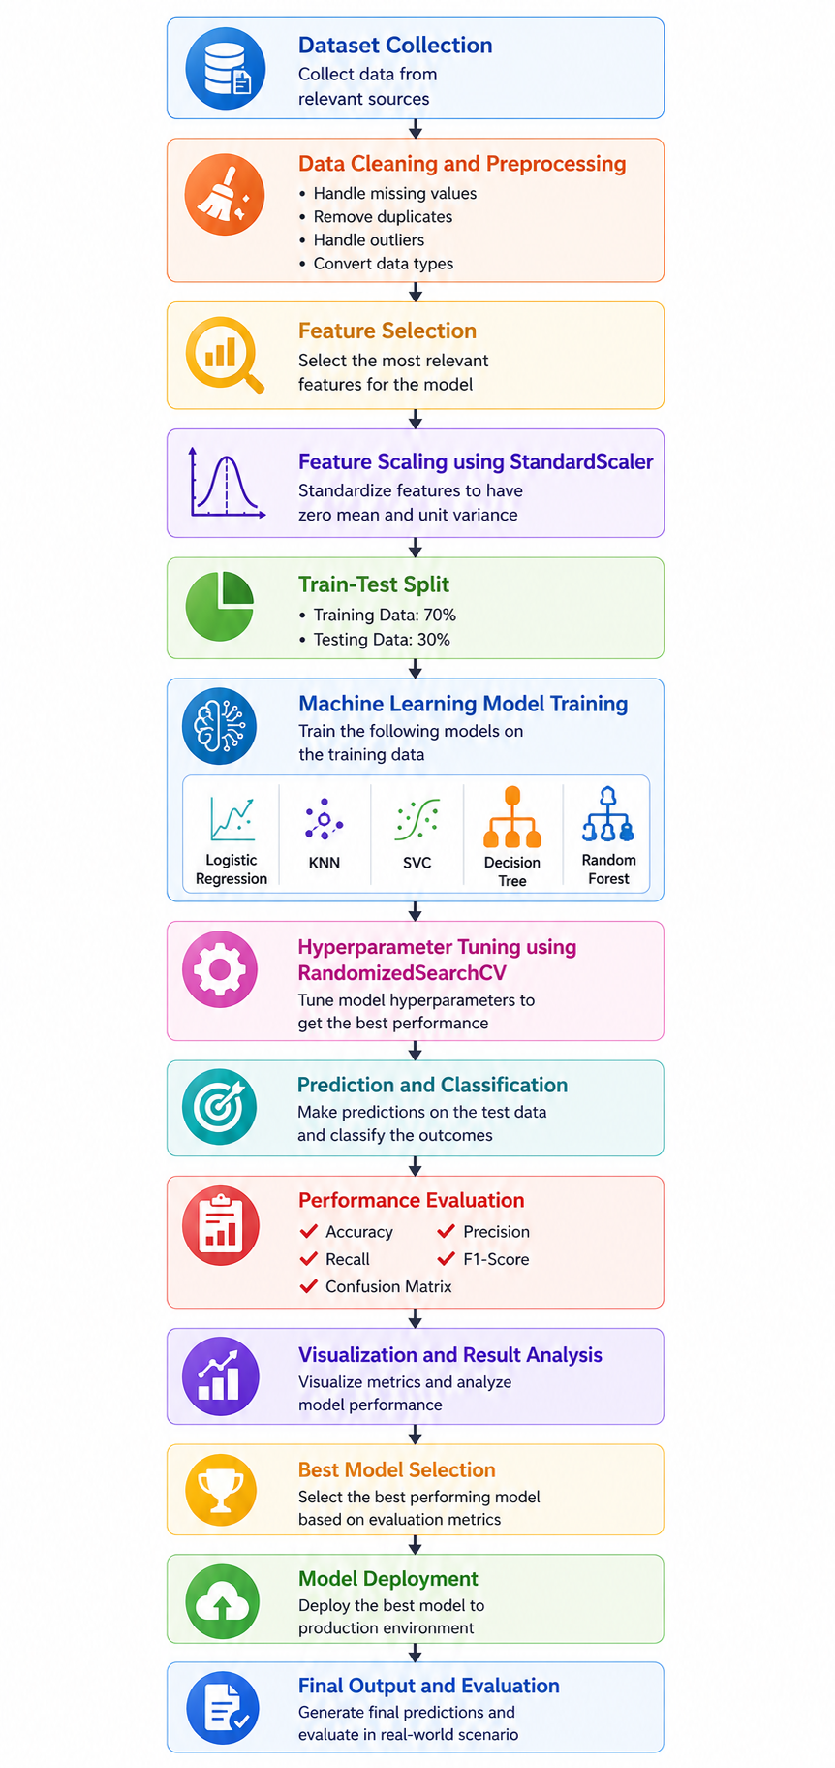

Fig.1 Machine Learning Pipeline

2. Modules for Project Implementation

2.1 Modules Used

1. Pandas
Pandas is used for data manipulation and analysis.
Functions Used
- pd.read_csv() – Reads dataset from CSV file
- DataFrame.head() – Displays first rows of dataset
- DataFrame.info() – Provides dataset information
- DataFrame.drop() – Removes unnecessary columns

2. NumPy
NumPy is used for numerical operations and array handling.
Functions Used
- np.array() – Creates arrays
- np.mean() – Calculates mean values
- np.std() – Calculates standard deviation

3. Matplotlib
Matplotlib is used for plotting graphs and visualizations.
Functions Used
- plt.plot() – Creates line graphs
- plt.figure() – Creates graph figure
- plt.show() – Displays plots

4. Seaborn
- Seaborn is used for advanced data visualization.
- Functions Used
- sns.heatmap() – Displays correlation heatmap
- sns.countplot() – Displays count plots

5. Scikit-learn
- Scikit-learn is used for machine learning implementation.

Functions Used
- train_test_split() – Splits data into train and test sets
- StandardScaler() – Performs feature scaling
- LogisticRegression() – Logistic Regression model
- KNeighborsClassifier() – KNN model
- DecisionTreeClassifier() – Decision Tree model
- RandomForestClassifier() – Random Forest model
- RandomizedSearchCV() – Hyperparameter tuning
- accuracy_score() – Calculates accuracy
- classification_report() – Displays precision, recall, and F1-score
- confusion_matrix() – Creates confusion matrix

2.2 Platform Used:

1. Jupyter Notebook
Jupyter Notebook is used for executing code step by step and visualizing outputs easily.

2. Python IDLE
Python IDLE is used for testing small code snippets and debugging basic programs.

- Machine Learning Model/ Searching Technique Used

1. Logistic Regression
Logistic Regression is a supervised classification algorithm used to predict whether network traffic is normal or malicious. It uses probability values for prediction.
Advantages
- Fast and efficient
- Easy to understand
- Suitable for binary classification

2. K-Nearest Neighbors (KNN)
KNN classifies data based on nearest neighbors using distance calculations.
Advantages
- Simple implementation
- Effective for pattern recognition
- Good classification accuracy

3. Decision Tree
Decision Tree creates a tree-like structure for classification decisions.
Advantages
- Easy visualization
- Handles numerical and categorical data
- Provides clear decision rules

4. Random Forest
Random Forest combines multiple decision trees for better prediction performance.
Advantages
- High accuracy
- Reduces overfitting
- Better generalization

5. Forward Feature Selection
Forward selection adds features one by one based on importance.
Advantages
- Improves efficiency
- Reduces unnecessary features

6. Backward Feature Elimination
Backward elimination removes less important features step by step.
Advantages
- Reduces model complexity
- Improves performance

4. Evaluation metrics used

1. Accuracy
Accuracy measures the overall correctness of predictions.
Formula
Accuracy = Correct Predictions / Total Predictions

2. Precision
Precision measures how many predicted attacks are actually correct.
Formula
Precision = TP / (TP + FP)

3. Recall
Recall measures how many actual attacks are correctly detected.
Formula
Recall = TP / (TP + FN)

4. F1-Score
F1-score balances precision and recall.
Formula
F1-score = 2 × (Precision × Recall) / (Precision + Recall)

5. Confusion Matrix
Confusion matrix displays:
- True Positives
- True Negatives
- False Positives
- False Negatives

5. Results and Visualizations

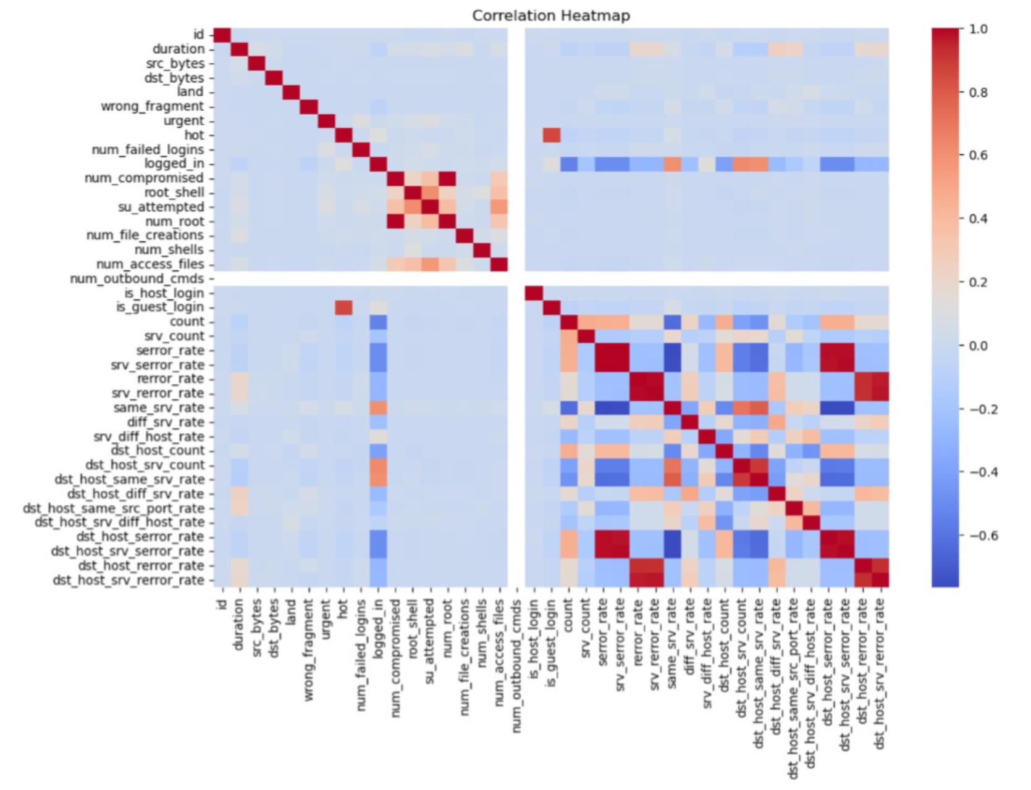
Fig.1 Heatmap showing correlation

The correlation heatmap visualizes relationships among numerical features in the intrusion detection dataset. Red regions indicate strong positive correlation, blue regions indicate negative correlation, and light colors show weak relationships. Several traffic and error-rate features exhibit high correlation, which helps identify important network behavior patterns useful for attack detection and feature selection in machine learning models.

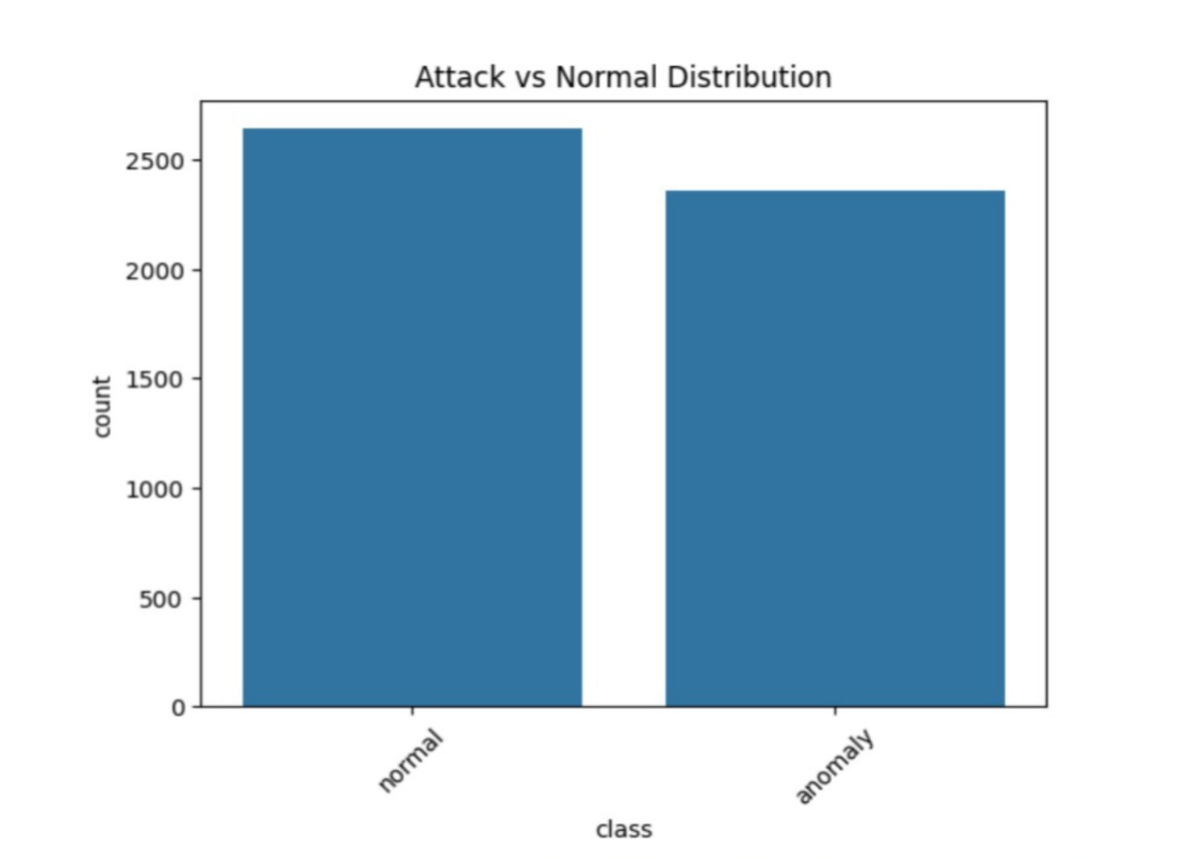

Fig.2 Attack Vs Normal Distribution

The class distribution between normal traffic and attack (anomalous) traffic is relatively balanced, with a slightly higher number of normal instances. In the context of a network intrusion detection system, this is advantageous because the model is exposed to sufficient examples of both legitimate and malicious network behavior during training. As a result, the model is less likely to become biased toward normal traffic and can better learn to identify intrusion patterns.

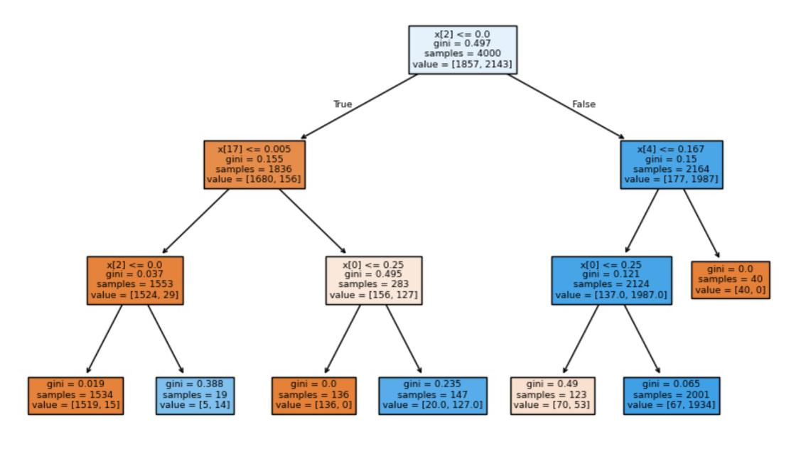
Fig 3: Decision Tree

The above figure represents the Decision Tree model used for Network Intrusion Detection. Decision Tree is a supervised machine learning algorithm that classifies network traffic by creating rule-based splits using different feature values. The tree starts from the root node containing all samples and gradually divides the data into smaller groups based on conditions that help distinguish normal traffic from malicious traffic. Each node displays the feature condition, Gini index, number of samples, and class distribution values. As the tree grows deeper, the Gini impurity decreases, resulting in more accurate classification. The model helps in identifying important network traffic patterns and provides fast, accurate, and easy-to-understand intrusion detection results.

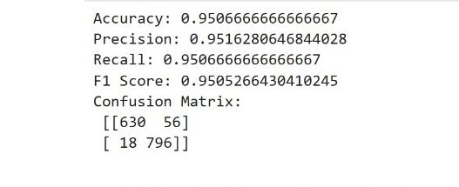

Fig 4: Precision,Recall,F1-score and support for Logistic Regression

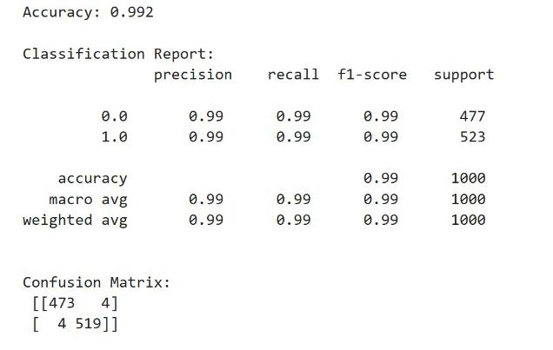

Fig 5: Precision,Recall,F1-score and support for Random Forest

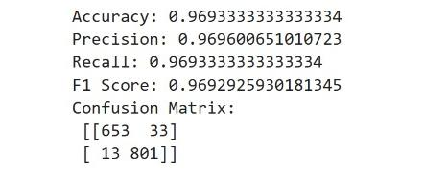

Fig 6: Precision,Recall,F1-score and support for KNN

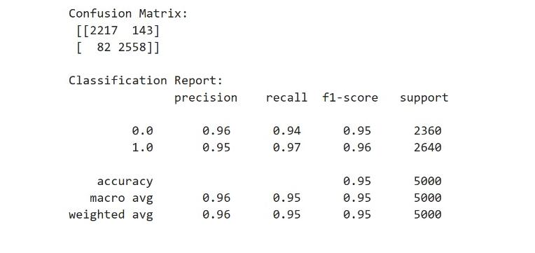

Fig 7: Precision,Recall,F1-score and support for SVC

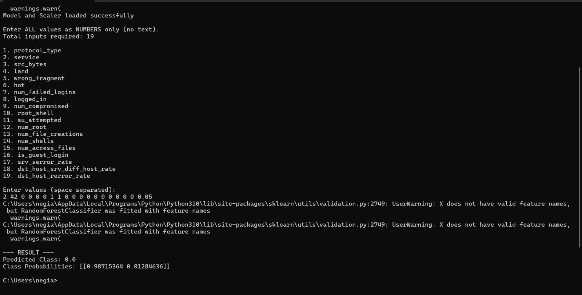

Fig 7: Network Intrusion Detection Prediction Results

6. Conclusion and Future Scope:

Conclusion

This project successfully demonstrates the use of machine learning techniques for detecting network intrusions in cyber security systems. Different machine learning models such as Logistic Regression, KNN, Decision Tree, and Random Forest were implemented and compared to identify malicious network traffic.
Feature selection techniques and hyperparameter tuning improved the efficiency and accuracy of the models. Evaluation metrics such as accuracy, precision, recall, and F1-score were used to analyze model performance.
The project shows that machine learning can effectively automate intrusion detection and improve cyber security systems.

Future Scope

Future improvements can include:
- Using deep learning models for better accuracy
- Real-time intrusion detection systems
- Integration with cloud-based cyber security systems
- Deployment as a web application
- Use of larger and more advanced datasets

7. References:
Books:
- Artificial Intelligence and Machine Learning – Vinod Chandra S.S.

Online Resources:
- https://www.kaggle.com/datasets/hassan06/nslkdd
- https://en.wikipedia.org/wiki/Machine_learning
- https://scikit-learn.org
- https://www.geeksforgeeks.org

